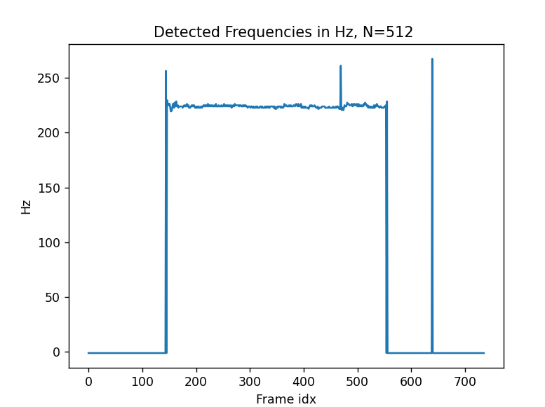

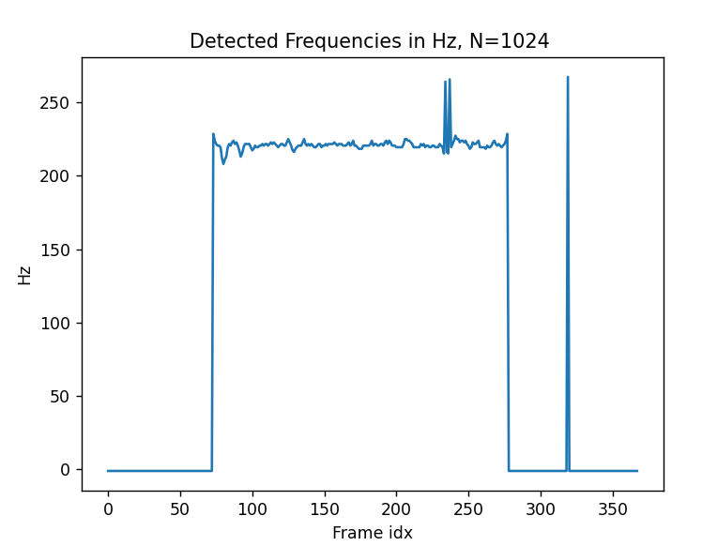

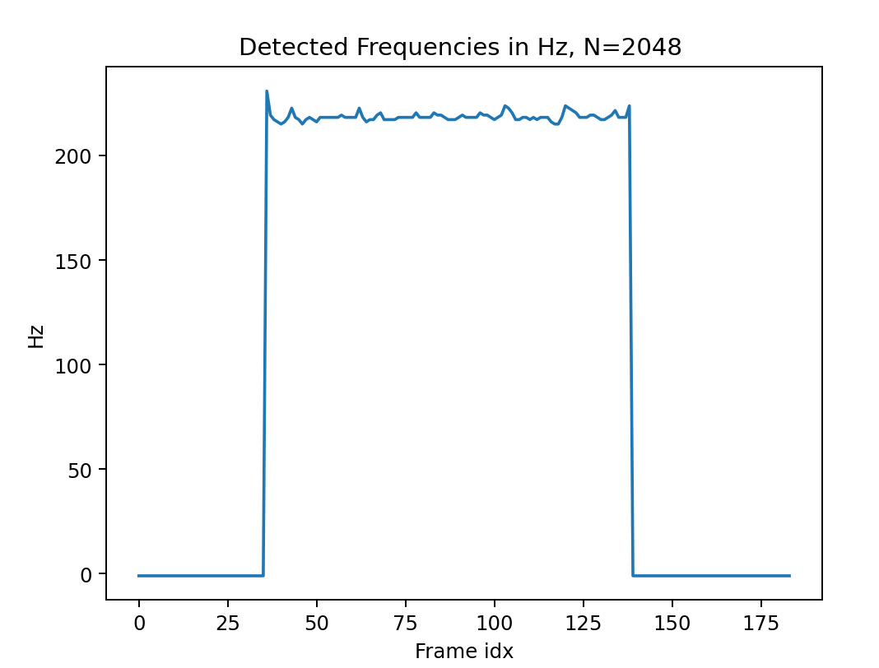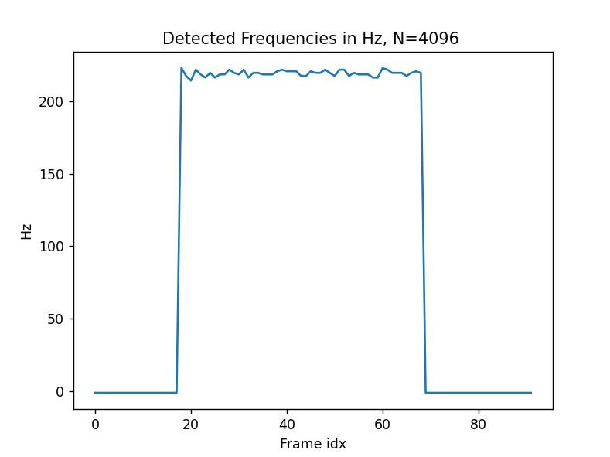

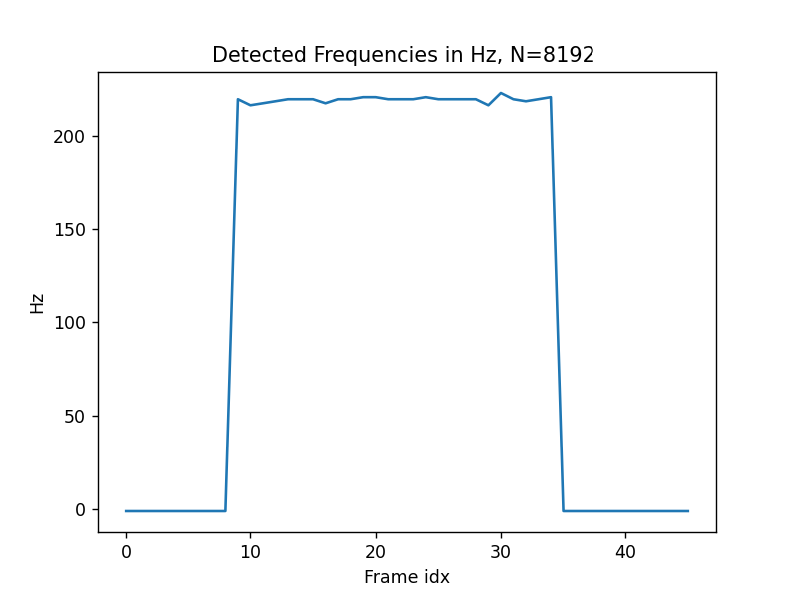

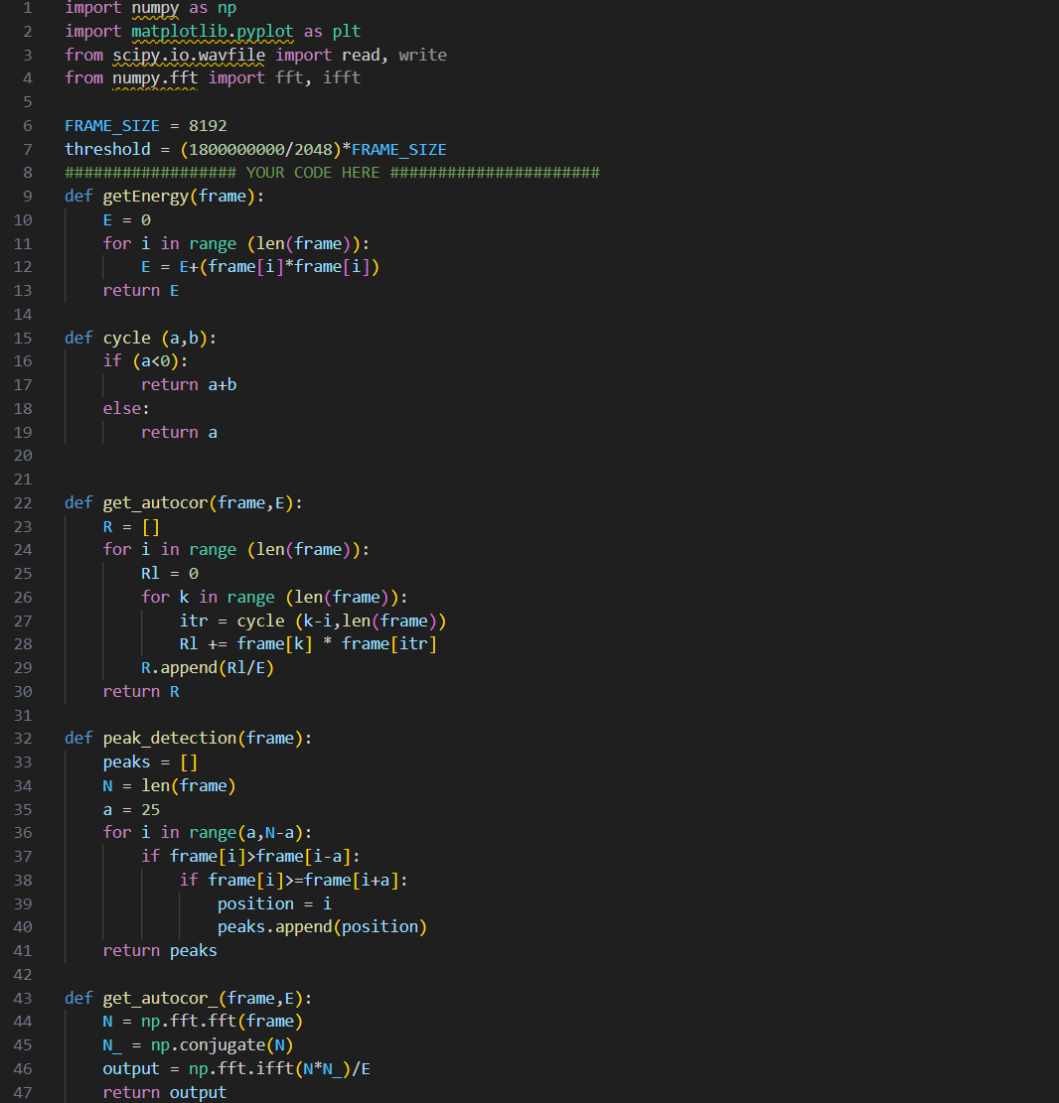

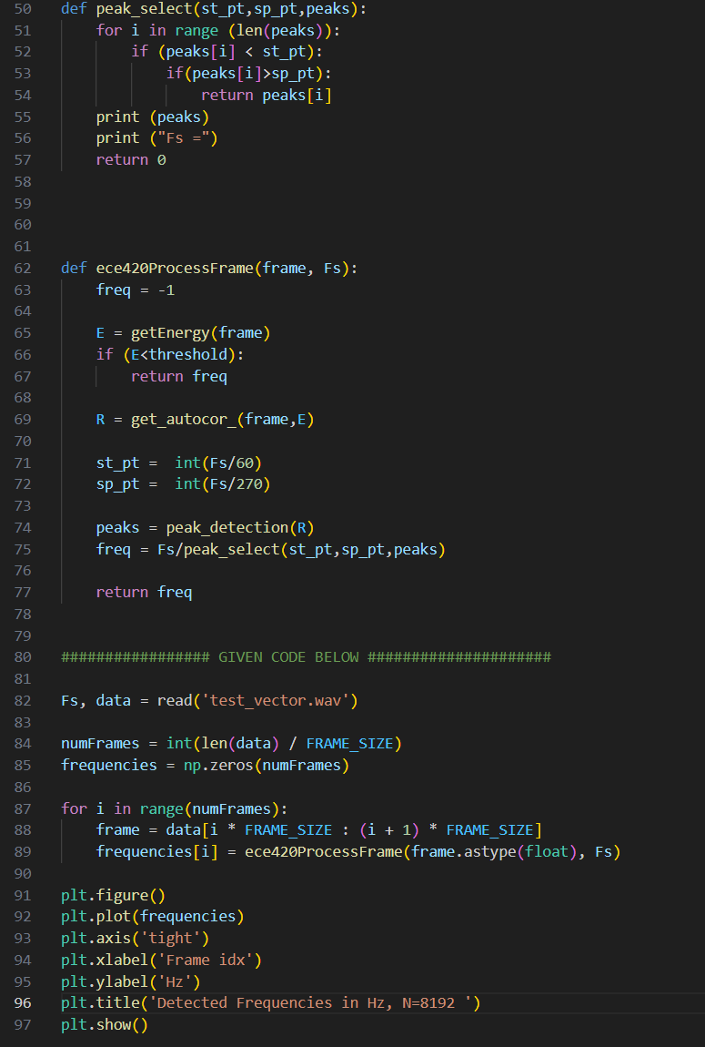

Question 1. I would ignore pitches outside of normal human voice range as shown in code (60Hz – 270Hz). Then I would take the first peak in that range.

Question 2. Same as above, I would ignore frequencies outside of human voice range, given the first peak and its surrounding is close to sampling frequency which is in the kHz range, we can ignore them.

Question 3. Since the lower bound of human voice is around 85Hz, this would give us around 11ms period. 40ms would insure we capture at least 1 period of the fundamental frequency and provide enough time resolution.